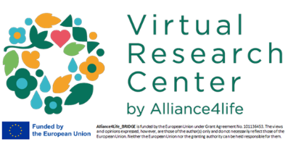
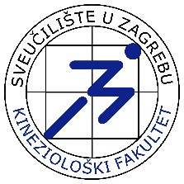
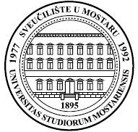
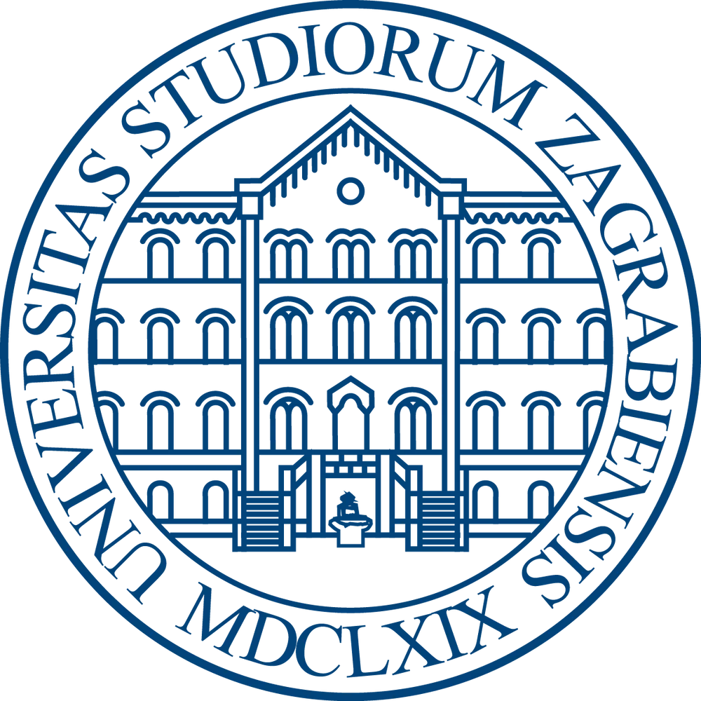
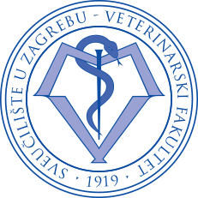
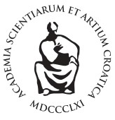
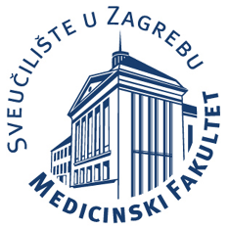
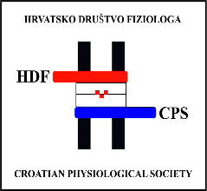
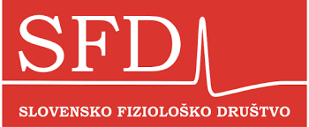
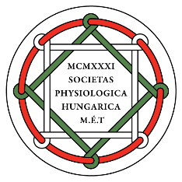
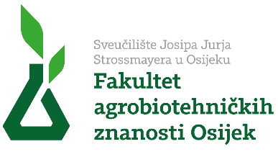
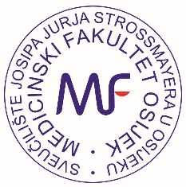

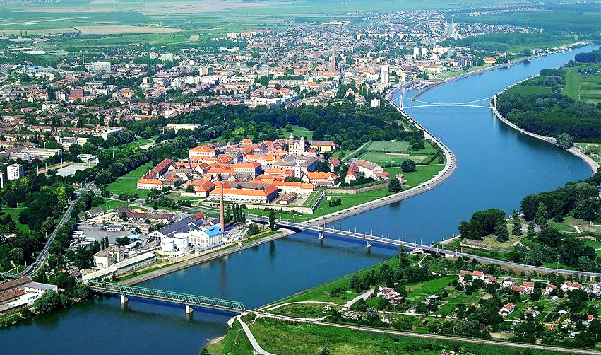

First Call Congress Programme

October 14 – 16, 2026, Osijek, Croatia

4th Regional Congress of Physiological Societies

and

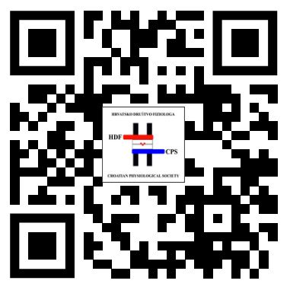
6th Congress of Croatian Physiological Society

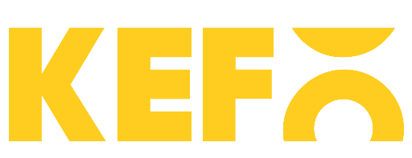
Sponsors and donations





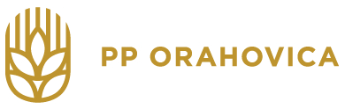

Wednesday, 14 October 2026

11:30 – 12:00 Registration and Welcome Coffee

12:00 – 12:30 Opening Ceremony
Welcome addresses

SESSION 1 — KEYNOTE & IMMUNOPHYSIOLOGY
Chairpersons: Ines Mrakovčić Šutić (Rijeka, Croatia), Ivan Ćavar (Mostar, Bosnia and Herzegovina)

12:30 – 13:15 KEYNOTE LECTURE (35 min + 10 min discussion)

Bojan Polić (University of Rijeka, Rijeka, Croatia)
The role of IFNg in systemic body adaptations to acute viral infections

13:15 – 13:35 INVITED LECTURE (15 + 5)

Dora Višnjić (University of Zagreb School of Medicine, Zagreb, Croatia)
From Metabolic Stress to Cell Cycle Arrest and Differentiation

13:35 – 13:55 INVITED LECTURE (15 + 5)
Ivan Ćavar (University of Mostar School of Medicine, Mostar, Bosnia and Herzegovina)
Serum concentrations of cytokines and PSA in patients with prostate adenocarcinoma

13:55 - 14:05 ORAL COMMUNICATION (8 + 2)
From selected abstracts

14:05 – 14:30 (25 min)
Coffee Break & Poster Session I

SESSION 2 — NEUROSCIENCE AND CEREBRAL PHYSIOLOGY
Chairpersons: Robert Zorec (University of Ljubljana, Slovenia), Marija Renić (Zagreb, Croatia)

14:30 – 14:50 INVITED LECTURE (15 + 5)

Marija Renić (University of Zagreb School of Medicine, Zagreb, Croatia)
Physiology of Cerebral Blood Flow

14:50 – 16:10 INVITED LECTURE (15 + 5)
Robert Zorec (Slovenian Physiological Society, University of Ljubljana, Ljubljana, Slovenia)
Adrenergic Regulation of Astrocytes in Health and Disease

16:10 – 16:30 INVITED LECTURE (15 + 5)
Nina Vardjan (Slovenian Physiological Society, University of Ljubljana, Ljubljana, Slovenia)
Lipid Droplets and Signalling in Astrocyte Stress Response

16:10 – 16:20 ORAL COMMUNICATION (8 + 2)
Vedrana Karan Rakić (University of Novi Sad, Novi Sad, Serbia)
Title TBA

16:20 – 16:30 ORAL COMMUNICATION (8 + 2)
Anemari Horvat (Slovenian Physiological Society, University of Ljubljana, Slovenia)
Elevated K⁺ Triggers Glycolytic Lactate Mobilisation Contributing to Astrocyte Swelling

16:30 – 16:40 ORAL COMMUNICATION (8 + 2)
Antonio Markotić (University of Mostar School of Medicine, Mostar, Bosnia and Herzegovina)
Effects of "Prime Energy" drink on cognitive and psychomotor functions

SESSION 3: ION CHANNELS AND DISEASE

Chairpersons: Toth Isztvan Balasz (Institute of Physiology, Medical School, University of Pécs, Pécs, Hungary), Hrvoje Lalić (Faculty of Medicine Zagreb University of Zagreb, Croatia)

16:40 - 17:00 INVITED LECTURE (15 + 5)
Gábor Tajti (Institute of Physiology, Center for Physiology and Pharmacology, Medical University of Vienna, Vienna, Austria)
Activation of TRPA1 affects the function of human fibroblast-like synoviocytes in rheumatoid arthritis

17:00 - 17:20 INVITED LECTURE (15 + 5)

Aleksandar Kibel (Faculty of Medicine Osijek, Priora International Čepin, Croatia)
The role of SGLT2 inhibitors in the treatment of heart failure

17:20 - 17:40 INVITED LECTURE (15 + 5)
Erika Lisztes (Department of Physiology, Faculty of Medicine, University of Debrecen, Debrecen, Hungary)
Role of TRPV4 in dermal skin regeneration

17:40 - 18:00 INVITED LECTURE (15 + 5)
Viktória Kormos (Department of Pharmacology and Pharmacotherapy, Medical School University of Pécs, Pécs, Hungary)
Examination of Edinger-Westphal nucleus-specific TRPA1 cKO mice in migraine.

18:00 - 18:20 INVITED LECTURE (15 + 5)
Miklós Kecskés (Institute of Physiology, Medical School University of Pécs, Pécs, Hungary) Role of TRPM3 in epilepsy

18:20-18:30 ORAL COMMUNICATION (8+2)
Ines Drenjančević (Faculty of Medicine Osijek, University of Osijek, Osijek, Croatia)
High salt diet affects flow-induced dilation via ion channels in Tff3-/-/C57BL/6N knockout and wild-type C57BL/6N mice

19:00 Welcome Reception

Thursday, 15 October 2026

SESSION 4 — VASCULAR PHYSIOLOGY, MICROCIRCULATION & ENDOTHELIAL FUNCTION
Chairpersons: Helena Lenasi (Slovenian Physiological Society, Ljubljana, Slovenia), Ana Stupin (Faculty of Medicine Osijek, Osijek, Croatia)

08:30 – 08:50 INVITED LECTURE (15 + 5)
Akos Koller (Hungarian Physiological Society, Budapest, Hungary)
The molecular mechanisms reflect the different flow-dependent responses of small extra- and intracerebral arteries

08:50 – 09:10 INVITED LECTURE (15 + 5)

Nataša Popović (University of Montenegro, Podgorica, Montenegro)
The Retina as a Window to Systemic Physiology: Translating Physiological Signals into Digital Biomarkers

09:10 – 09:30 INVITED LECTURE (15 + 5)
Zrinka Mihaljević (Faculty of Medicine Osijek, Osijek, Croatia)
Hyperbaric Oxygenation as a Modulator of Endothelial Function: Insights into Redox and Vasodilatory Pathways

09:30 – 09:50 INVITED LECTURE (15 + 5)
Aleksandra Dugandžić (Faculty of Medicine Zagreb, Croatia)
Different roles of brown adipose tissue and brain uroguanylin in males and females

09:50 - 10:00 ORAL COMMUNICATION (8 + 2)
From selected abstracts

10:00 – 10:10 ORAL COMMUNICATION (8 + 2)
From selected abstracts

10:10 – 10:45 (35min)
Coffee Break & Poster Session II

10:45 – 11:05 INVITED LECTURE (15 + 5)
Bari Ferenc (University of Szeged, Szeged, Hungary)
Title TBA

11:05 – 11:25 INVITED LECTURE (15 + 5)

Helena Lenasi (University of Ljubljana, Ljubljana, Slovenia)
Impact of thyroid dysfunction on (micro)vascular and autonomic nervous system (re)activity

11:25 – 11:35 ORAL COMMUNICATION (8 + 2)
Danilo Radunović (University of Montenegro, Podgorica, Montenegro)
Molecular basis of pulse wave velocity (PWV) and its clinical significance

11:35 – 11:45 ORAL COMMUNICATION (8 + 2)

Vladimir Prelević (University of Montenegro, Podgorica, Montenegro)
Chronic kidney disease as a model of early vascular ageing

11:45 - 11:55 ORAL COMMUNICATION (8 + 2)
Danijel Pravdić (Faculty of Medicine Mostar, Bosnia and Herzegovina)
The role of mitochondria in cardioprotection

11:55 -12:15 INVITED LECTURE
Filip Sedlić (Faculty of Medicine Zagreb, Virtual Research Centre All4Life)
Human myocardial miRNA expression in heart failure

12:15 – 12:25 ORAL COMMUNICATION (8 + 2)
From selected abstracts

12:25 –13:10 (45 min)
Lunch Break

SESSION 5 — AI, BIOMEDICAL SIGNALS & TRANSLATIONAL TECHNOLOGIES
Chairpersons: Igor V. Pantić (Belgrade, Serbia), Mirza Žižak (Zagreb, Croatia)

13:10 – 13:30 INVITED LECTURE (15 + 5)
Mirza Žižak (University of Zagreb School of Medicine, Zagreb, Croatia)
AI-Supported Flipped Classroom approach: Transforming the role of teachers in medical education

13:30 – 13:50 INVITED LECTURE (15 + 5)
Igor V. Pantić (University of Belgrade, Faculty of Medicine Belgrade, Serbia)
A Fractal-Feature Neural Network for Quantitative Analysis of Two-Dimensional Physiological Signals

13:50 – 14:00 INVITED LECTURE (15 + 5)
Dragan Mirkov (University of Belgrade, Belgrade, Serbia)
Neuromechanics of the Countermovement Jump: From Neural Drive to Take-Off Velocity

14:00 – 14:10 ORAL COMMUNICATION (8 + 2)
From selected abstracts

14:10 – 14:20 ORAL COMMUNICATION (8 + 2)
From selected abstracts

14:20 - 14:30 ORAL COMMUNICATION (8 + 2)
From selected abstracts

SESSION 6 – POSTTRAUMATIC STRESS DISORDER: FROM BENCH TO BEDSIDE (session organized by Hungarian Physiological Society)
Chairpersons: Dora Timea Zelena (University of Pecs, Institue of Physiology, Pecs, Hungary) and Nikola Habek (Faculty of Medicine Zagreb, Croatia)

14:30-14:50 INVITED LECTURE (15 + 5)
Dubrovka Švob-Strac (Institute Rudjer Boskovic, Zagreb, Croatia)
Title: The Biology of Trauma: Searching for PTSD Biomarkers

14:50 – 15:10 INVITED LECTURE (15 + 5)
Dóra Zelena (University of Pécs, Institute of Physiology, Pécs, Hungary)
Title: Metabolic consideration of PTSD

15:10 – 15:30 INVITED LECTURE (15 + 5)
Ana Havelka Meštrović (Algebra Bernays University, Zagreb, Croatia)
Title: Psychophysiological studies in combat PTSD

15:30-15:50 INVITED LECTURE (15 + 5)
Viktória Kormos (University of Pécs, Department of Pharmacology and Pharmacotherapy, Pécs, Hungary)
Title: Transient receptor potential ankyrin 1 ion channels may control the stress adaptation and fear conditioning in a mouse model of posttraumatic stress disorder

20:00 - 24:00 Conference Dinner
(Restaurant Projekt 9, Gornjodravska obala bb, 31000, Osijek)

Friday, 16 October 2026

SESSION 7 — EXPERIMENTAL MODELS, EDUCATION & ETHICS
Chairpersons: Vladiana Crljen (Faculty of Medicine Zagreb, Croatia), Ivana Jukić (Faculty of Medicine Osijek, Croatia)

08:30 – 08:50 INVITED LECTURE (15 + 5)
Mario Ostović (Faculty of Veterinary Medicine, University of Zagreb, Zagreb, Croatia)
Using animals in biomedical research: Welfare issues and alternatives

08:50 – 09:10 INVITED LECTURE (15 + 5)
Ivan Alić (Faculty of Veterinary Medicine, University of Zagreb, Zagreb, Croatia)
In vitro models in biomedical research

09:10 – 09:20 ORAL COMMUNICATION (8 + 2)
Ana Shek Vugrovečki (Faculty of Veterinary Medicine, University of Zagreb, Zagreb, Croatia)
Are Non-Animal Models Effective in Veterinary Education? Insights from Our Teaching Practice

09:20 – 09:30 ORAL COMMUNICATION (8 + 2)

From selected abstracts

09:30 - 09:40 ORAL COMMUNICATION (8 + 2)
Vladiana Crljen (Faculty of Medicine Zagreb, Croatia)
Title TBA

09:40 – 10:25 (45 min)
Coffee Break & Poster Session III

10:25 – 11:10 PLENARY LECTURE (35 + 10)

Janoš Terzić (Faculty of Medicine Split, Croatia)

The role of microbiota and inflammation in urinary bladder cancer

SESSION 8 — CELL PHYSIOLOGY, IMMUNOLOGY & TRANSLATIONAL RESEARCH (part I)
Chairpersons: Ines Drenjančević (Faculty of Medicine Osijek, Croatia), Dora Višnjić (Faculty of Medicine Zagreb, Croatia)

11:10 – 11:30 INVITED LECTURE (15 + 5)
Markus Ritter (Paracelsus Medical University, Salzburg, Austria)
On the manifold functions of the non-gastric H⁺/K⁺-ATPase ATP12A

11:30 – 11:50 INVITED LECTURE (15 + 5)
Aleksandra Popović (University of Novi Sad, Novi Sad, Serbia)
Functional Analysis of Mitochondria in Permeabilized Muscle Fibers, Tissues, and Cultured Cells

11:50 – 12:00 ORAL COMMUNICATION (8 + 2)
Ivo Krešić (University of Mostar School of Medicine, Mostar, Bosnia and Herzegovina)
Monocyte functional heterogeneity in psoriatic arthritis and ankylosing spondylitis

12:00 – 12:10 ORAL COMMUNICATION (8 + 2)
Pavao Planinić (University of Mostar School of Medicine, Mostar, Bosnia and Herzegovina)
Bone biology in murine models of cholestatic liver injury

12:10 – 12:50 (40 min)
Lunch Break

SESSION 8 — CELL PHYSIOLOGY, IMMUNOLOGY & TRANSLATIONAL RESEARCH (part II)
Chairpersons: Ines Mrakovčić Šutić (Faculty of Medicine Rijeka, Croatia), Dora Višnjić (Faculty of Medicine Zagreb, Croatia)

12:50 – 13:10 INVITED LECTURE (15 + 5)
Jovana Paunović Pantić (University of Belgrade, Faculty of Medicine Belgrade, Serbia)
Recent Advances in Laser-Based Technologies for Tissue Regeneration

13:10 - 13:30 INVITED LECTURE (15 + 5)

Vlatka Sotošek (University of Rijeka, Rijeka, Croatia)
Endothelial glycocalyx in health and disease

13:30 – 13:50 INVITED LECTURE (15 + 5)

Ana Ugrinska (Medical Faculty, University " Ss Cyril and Methodius" Skopje

Republic of North Macedonia)

The Role of Monounsaturated Fatty Acids on Body Composition, Metabolic Health & Weight Management

13:50 – 14:10 INVITED LECTURE (15 + 5)

Helena Haque Chowdhury (Faculty of Medicine University of Ljubljana, Slovenia)

Advanced Therapy Medicinal Products Are Transforming the Future of Medicine: Clinical Outcomes and Future Directions of the Cell-Based ATMP aHyc for Prostate Cancer

14:10 – 14:30 INVITED LECTURE (15 + 5)

Andraž Stožer (Faculty of Medicine University of Maribor, Slovenia)

From spikes to strikes:

Calcium oscillations in beta cells and their changes during development of type 2 diabetes

SESSION 9 - FROM IMMUNOBIOLOGY OF PSORIASIS TO CLINICAL DISEASE CONTROL: IL-23 BLOCKADE WITH RISANOKIZUMAB AND THE POTENTIAL OF DIETARY INTERVENTIONS

14:30 - 16:00
Chairpersons: Melita Vukšić Polić (Faculty of Medicine Osijek, Clinical Hospital Centre Osijek, Croatia), Martina Mihalj (Faculty of Medicine Osijek, Clinical Hospital Centre Osijek, Croatia)

SPEAKERS:
- Ivana Krajina
- Vera Plužarić
- Stana Tokić
(3 × 20 min lectures + panel discussion)

16:00
Closing Remarks and Awards

